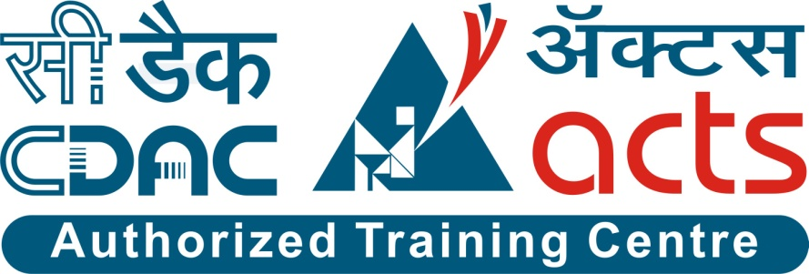

Project Name: Online Electricity Bill Management System

Branch PG-DAC March-2022

Documentation On

**“Online Electricity Bill Management System”**

PG-DAC MARCH 2022

**Guided By: Prathamesh Naik**

Submitted By :

**Group No: 15**

* **Ravindra Mohite 220343020050**
* **Priya Patil 220343020065**
* **Shruti Patil 220343020066**
* **Varsha Patil 220343020069**

**Table of Contents**

**1. Introduction 4**

1.1 Document Purpose **4**

1.2 Project Background **4**

1.3 Aim & Objectives **4**

**2. Business Requirements Overview**…………………………………………………………**5**

**3.Functional Requirements** **6**

3.1 Consumer Module **6**

3.2 Sub-Admin Module **6**

3.3 Admin Module **6**

**4.** **Non-Functional Requirement………………………………………………………………7**

**5. Use Case Diagram 8**

5.1 Admin **9**

5.2 Sub-Admin **10**

5.3 Consumer **11**

**6. Database Design 12**

1 Users **12**

2 Admin **12**

3 Sub-Admin...……………………………………………………………………………..**13**

4 Consumer **13**

5 Zone **13**

6 Bills **13**

7 Payment details **13**

**7. E-R Diagram………………………………………………………………………………………14**

**8. Snapshots 15**

**9. Conclusion 20**

**List of Figures**

**Use Case Diagrams 17**

Fig 1 Admin 8

Fig 2 Sub-Admin 9

Fig 3 Consumer 10

Fig 4 ER Diagram 14

1. **Introduction:**
   1. **Document Purpose:**

This document communicates the business requirements and scope for developing Online Electricity Bill Management System. The scope of this document is to define the functional and non functional requirements, business rules and other constraints requirements.

## Project Background:

This system is made to keep the records about the bills of the consumers. In current system getting previous data of paid bills is difficult task. Payment of the bills using current system is also difficult task.

## Aim & Objectives:

The main objective of this project is building a website which will help to manage the details of electricity bills, connections, store records and consumers. Sub-admins are allocated on the basis of different regions. Here if suppose anyone wants to use this facility and pay electricity bills online then they must have knowledge of computer. After that they can directly register in the portal by providing their valid details and pay electricity bill online.

This system has the option for consumers to pay their electricity bills by online mode through card payment. This system also has the feature to add and delete consumers and sub-admin accounts, in case a consumer wants to cut the connection or a sub-admin wants to leave the job.

1. **Business Requirements Overview:**

* Online Electricity Bill Management System is a public web application.
* Online Electricity Bill Management System will be available for all consumers which want to pay their electricity bills online by using this portal.
* There are mainly three types of users.
* To register on this portal consumers should provide their valid Email-id and Contact number.
* Consumer can view details of electricity bills by logging into their account.
* Admin, sub-admin can search electricity bill payment details and even information about the consumer by using a unique id which is generated for every consumer.
* Online Electricity Bill Management System could be maintained by Admin.

# Functional Requirements Overview:

Online Electricity Bill Management System consists of three modules described below:-

1. Admin Module
2. Sub-admin Module
3. Consumer Module

**3.1 Admin:**

Enter Admin Email-Id and Password.

* + Display the Admin dashboard where he can see his profile and update his profile.
  + Admin can add Admin, Sub-Admin and Consumer.
  + View number of consumers.
  + Can view bill reports by searching particular consumer Id.
  + Can see payment report by searching a particular consumer Id.
  + Generate bills by searching particular consumer Id.

**3.2** **Sub-Admin:**

Enter Sub-Admin Email-Id and Password.

* Display the Sub-Admin dashboard where he can see his profile and update his profile.
* View number of consumers.
* Generate bills by searching particular consumer Id.
* Can view bill report by searching particular consumer Id.
* Can see payment report by searching particular consumer Id.

**3.3 Consumer:**

Enter consumer Email-Id and Password

* Display the consumer dashboard where he can see his profile and update his profile.
* View current bill and also pay bill and print bill.
* Consumer can view bill history.
* Consumer can view payment history.

1. **Non-Functional Requirement:**

* The website should use professional design, look and feel and color scheme.
* Users will have no limitations for accessing the application through Internet. The portal being an internet application, it is difficult specify exact number of visitor or users. Hence we will target the system to support between 5 and 10 million users on launch of phase 1.
* Being a public website, the site must follow general usability guidelines for menus, navigation, colors, links and other actions provided on the screens.
* The system should be designed in such a manner that user will be able to complete tasks in minimum number of steps.

.

## 5. Use-Case Diagram

**5.1 Admin:**

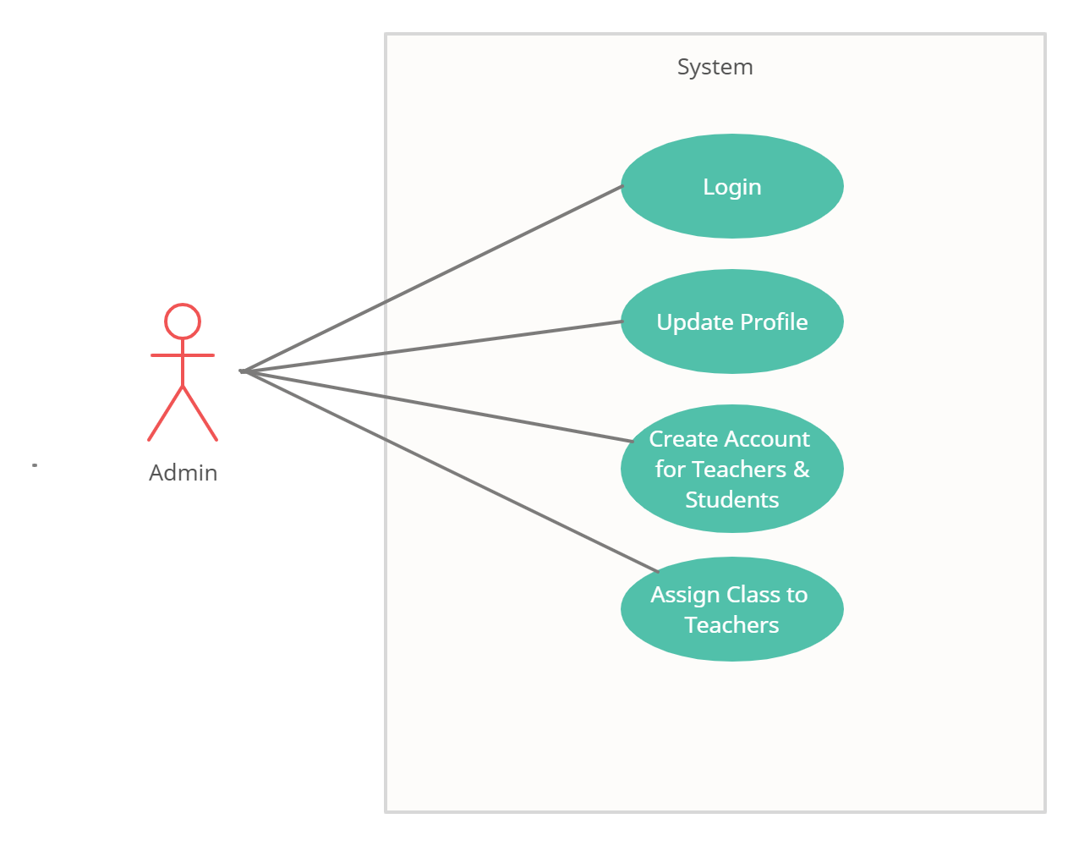

Fig. Use-Case Diagram for Admin

## 5.2 Student:

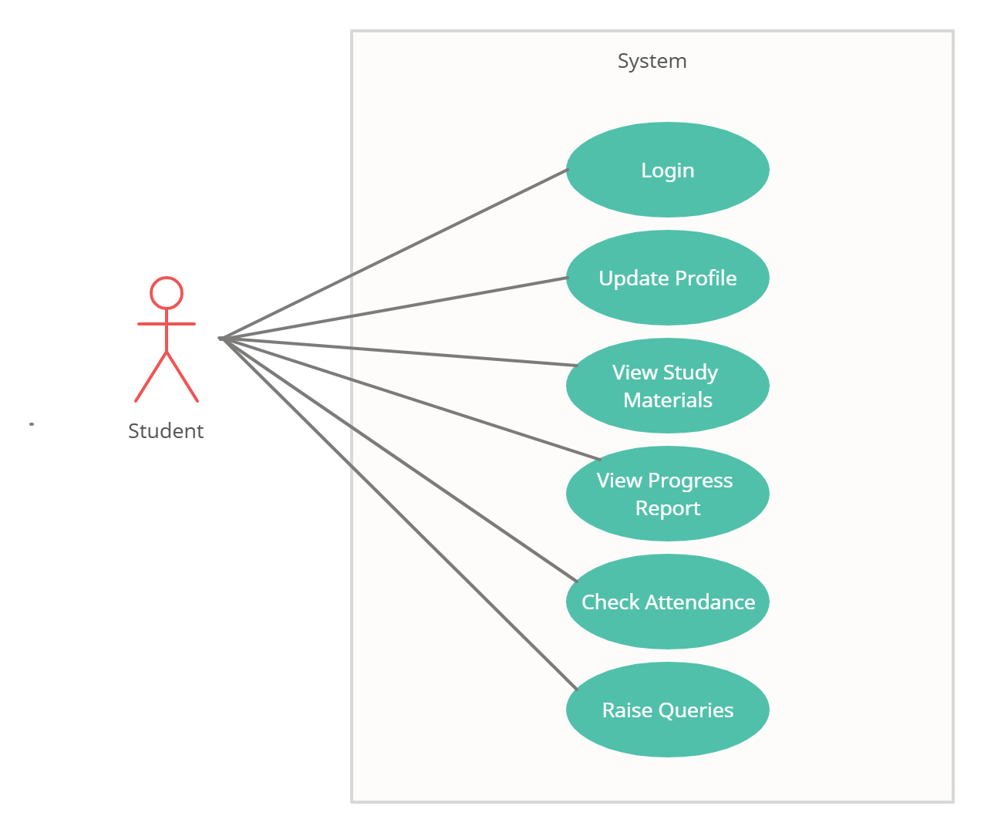

Fig. Use-Case Diagram for Student

**5.3 Teacher:**  
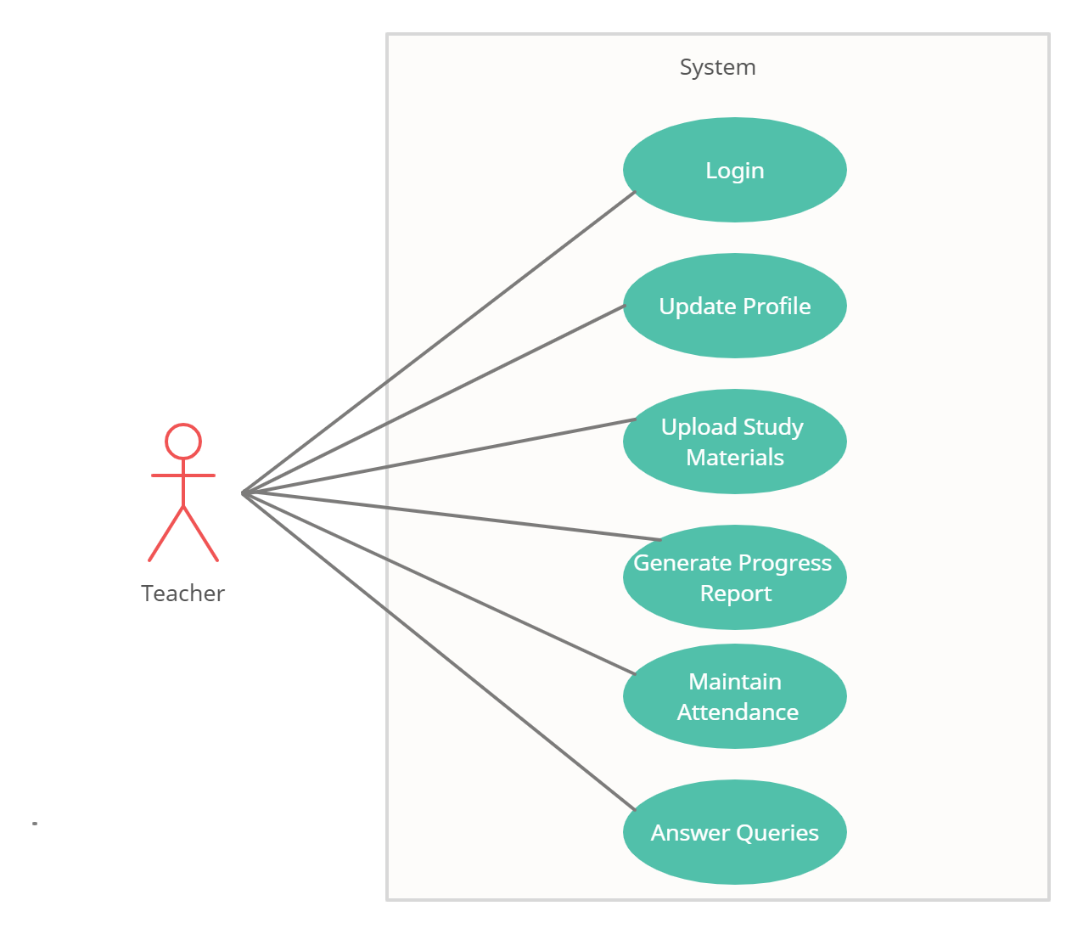

Fig. Use-Case Diagram for Teacher

**6. Database Design:**

**1] users table**

|  |  |  |  |
| --- | --- | --- | --- |
| **Fields** | **Data types** | **Constraints** | **Description** |
| user_id | int | PK,AI | User ID |
| email | varchar(40) | Unique,NN | Email address |
| password | varchar(25) | NN | Password |
| role | varchar(10) | NN | User role |

**2] admin table**

|  |  |  |  |
| --- | --- | --- | --- |
| **Fields** | **Data types** | **Constraints** | **Description** |
| user_id2 | int | FK | User ID |
| admin_id | int | PK,AI | Admin ID |
| name | varchar(40) | NN | Name |
| mobile_no | varchar(10) | NN | Mobile number |
| address | varchar(100) | NN | Address |
| city | varchar(30) | NN | City |
| email | varchar(40) | Unique, NN | Email address |
| state | varchar(30) | NN | State |
| zone_id2 | int | FK | Zone ID |

**3] sub_admin table**

|  |  |  |  |
| --- | --- | --- | --- |
| **Fields** | **Data types** | **Constraints** | **Description** |
| user_id1 | int | FK | User ID |
| subadmin_id | int | PK,AI | Sub Admin ID |
| name | varchar(40) | NN | Name |
| mobile_no | varchar(10) | NN | Mobile number |
| address | varchar(100) | NN | Address |
| city | varchar(30) | NN | City |
| email | varchar(40) | Unique, NN | Email address |
| state | varchar(30) | NN | State |
| zone_id1 | int | FK | Zone ID |

**4] consumer table**

|  |  |  |  |
| --- | --- | --- | --- |
| **Fields** | **Data types** | **Constraints** | **Description** |
| user_id | int | FK | User ID |
| consumer_id | int | PK,AI | Consumer ID |
| name | varchar(40) | NN | Name |
| mobile_no | varchar(10) | NN | Mobile number |
| address | varchar(100) | NN | Address |
| city | varchar(30) | NN | City |
| email | varchar(40) | Unique, NN | Email address |
| state | varchar(30) | NN | State |
| zone_id | int | FK | Zone ID |

**5] zone table**

|  |  |  |  |
| --- | --- | --- | --- |
| **Fields** | **Data types** | **Constraints** | **Description** |
| zone_id | int | PK,AI | zone_id |
| zone_name | varchar(15) | NN | zone_name |

**6] bills table**

|  |  |  |  |
| --- | --- | --- | --- |
| **Fields** | **Data types** | **Constraints** | **Description** |
| bill_id | int | PK,AI | Bill ID |
| consumer_id | int | FK | Consumer ID |
| units | int | NN | Units consumed |
| current_billAmt | double | NN | Current bill amount |
| dues | double | NN | Dues |
| fine | double | NN | Fine |
| total_billAmt | double | NN | Total bill amount |
| tax | double | NN | Tax |
| bill_date | date | NN | Bill date |
| due_date | date | NN | Due date |
| status | varchar(20) | NN | Status |

**7] payment_details table**

|  |  |  |  |
| --- | --- | --- | --- |
| **Fields** | **Data types** | **Constraints** | **Description** |
| payment_no | int | PK,AI | Payment ID |
| consumer_id1 | int | FK | Consumer ID |
| bill_id | int | FK | Bill ID |
| name | varchar(40) | NN | Name |
| payment_date | date | NN | Payment date |
| total_billAmt | double | NN | Total bill amount |
| card_type | varchar(15) | NN | Card type |
| card_no | varchar(16) | NN | Card no |
| cvv | varchar(4) | NN | CVV |
| exp_date | date | NN | Expiry date |

## 7. ER-Diagram:

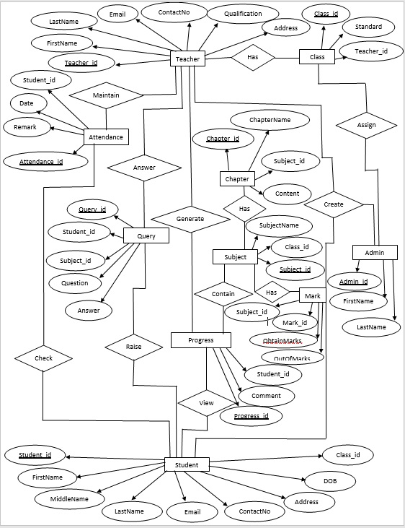

**E-R diagram shows database of Paperless School Management System**

**8. Snapshots:**

**8.1 Home Page:**

Following snapshot shows the Home page for Paperless School Management System

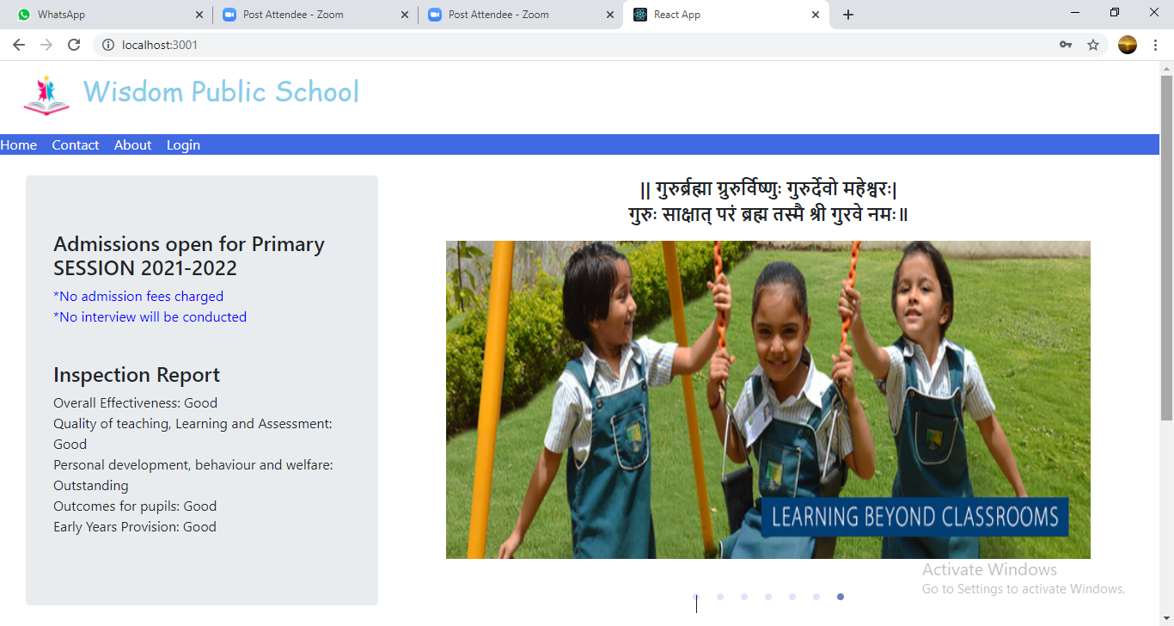

This page contains following controls

* Home
* Contact
* About
* Login Button

**8.2 Contact Page**

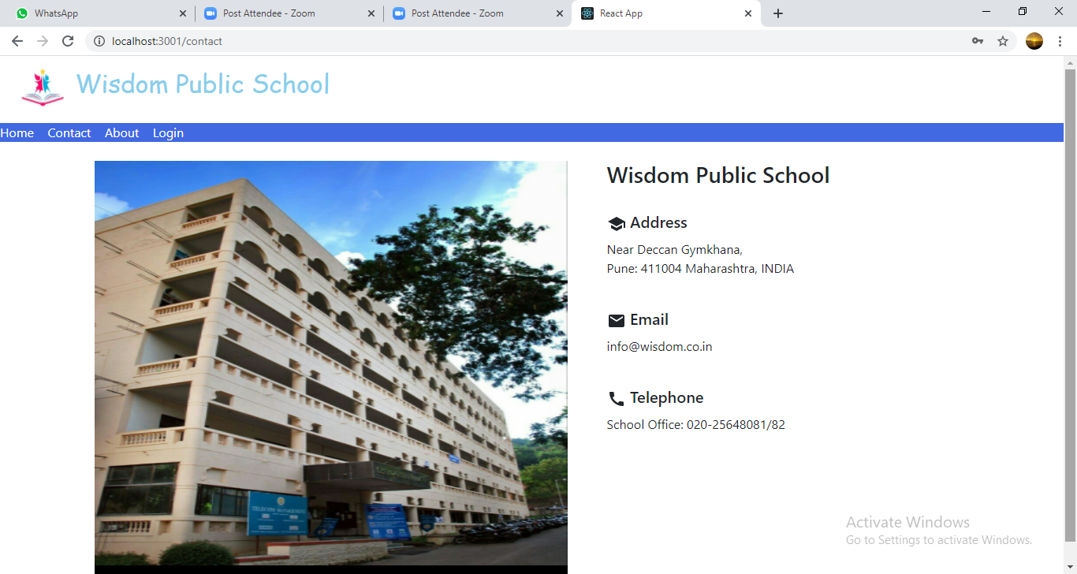

**8.3 About Page**

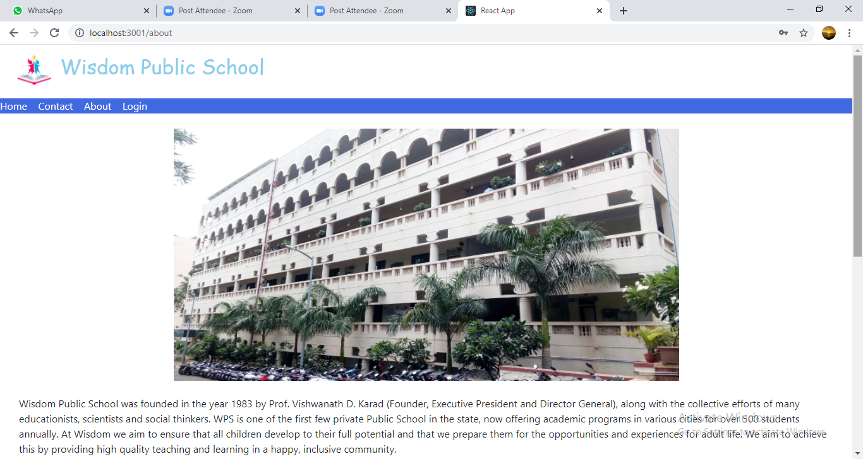

**8.4 Login Page**

Following snapshot shows the Login page for Paperless School Management System

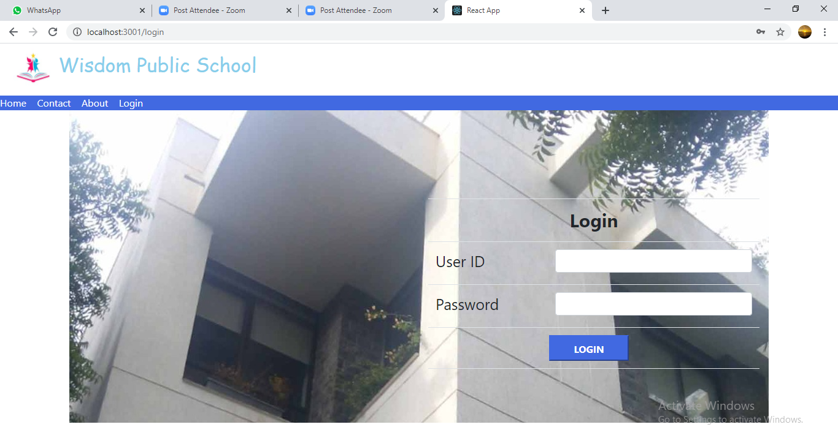

**8.5 Admin Home Page**

**8.5.1 Student Registration Page**

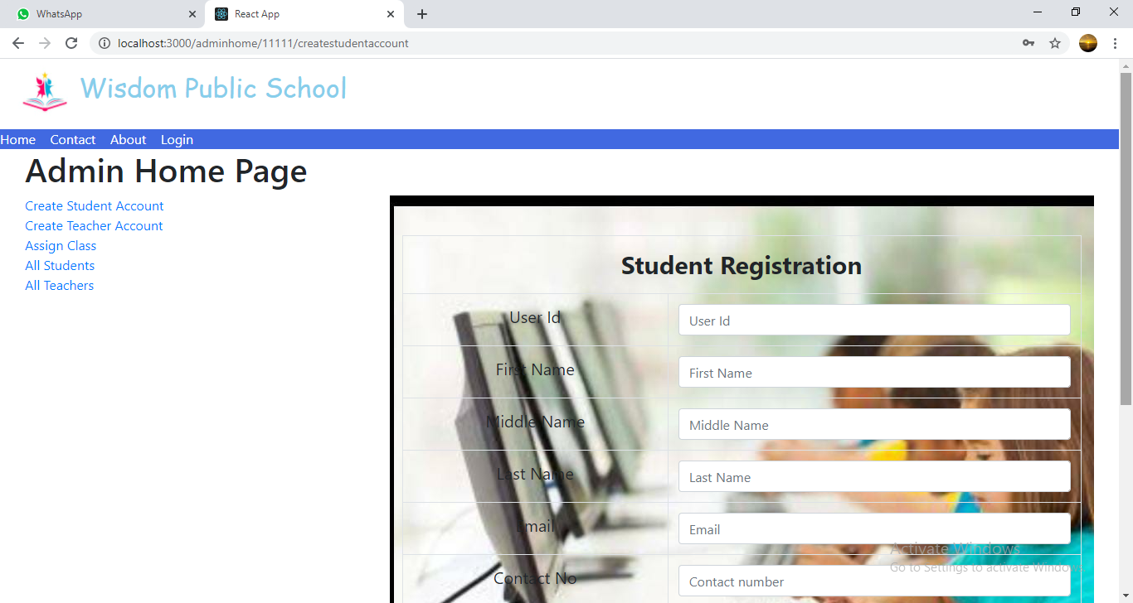

**8.5.2 Teacher Registration Page**

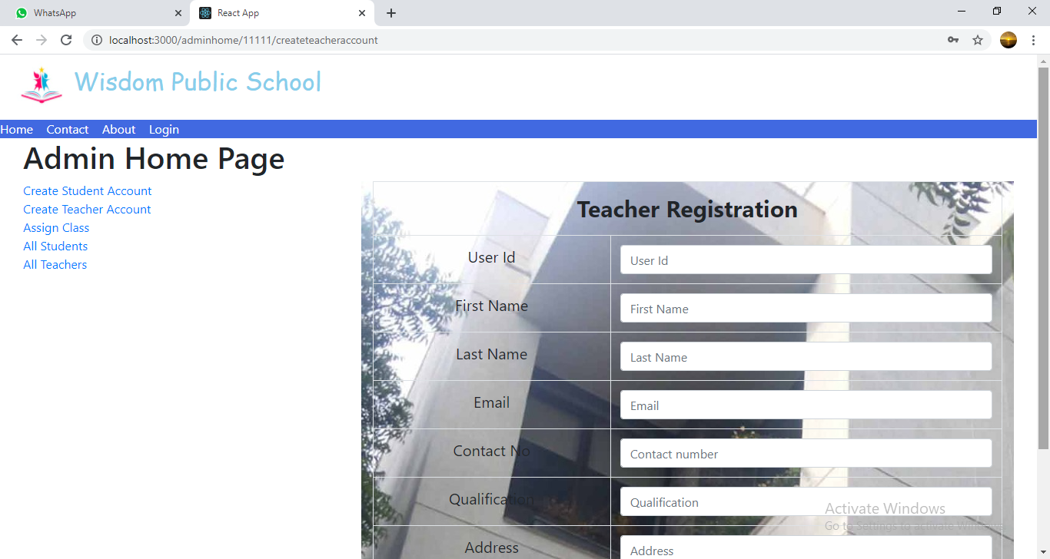

**8.5.3 Assign Class Page**

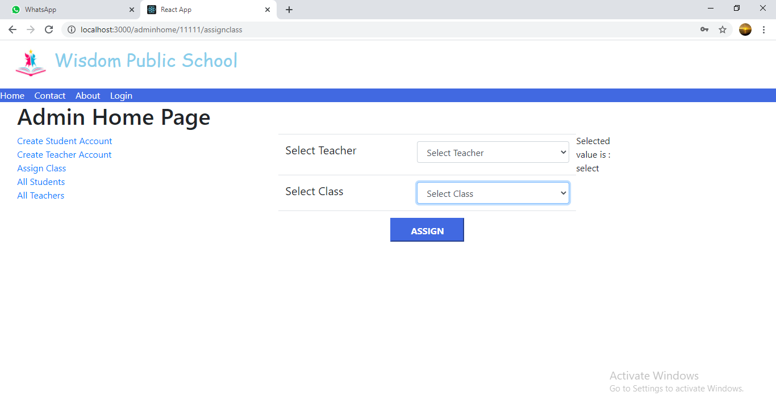

**8.5.4 All Students List**

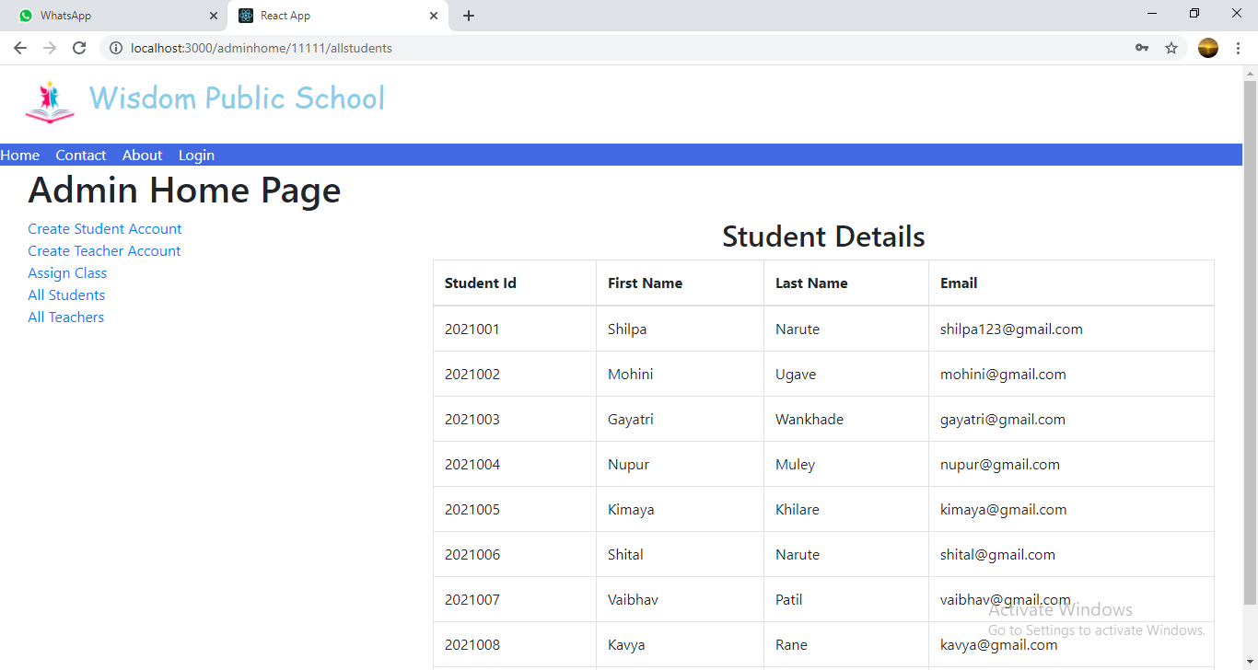

**8.5.5 All Teachers List**

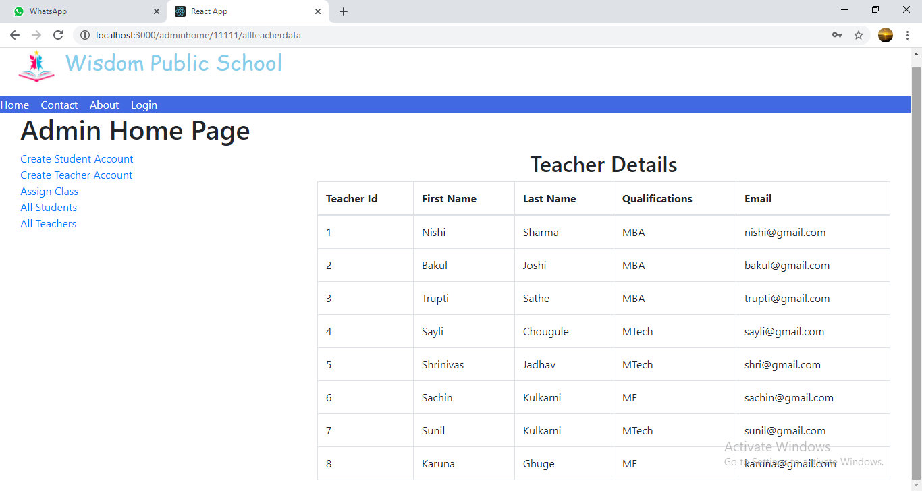

**8.6 Teacher Home Page**

**8.6.1 Upload Study Material Page**

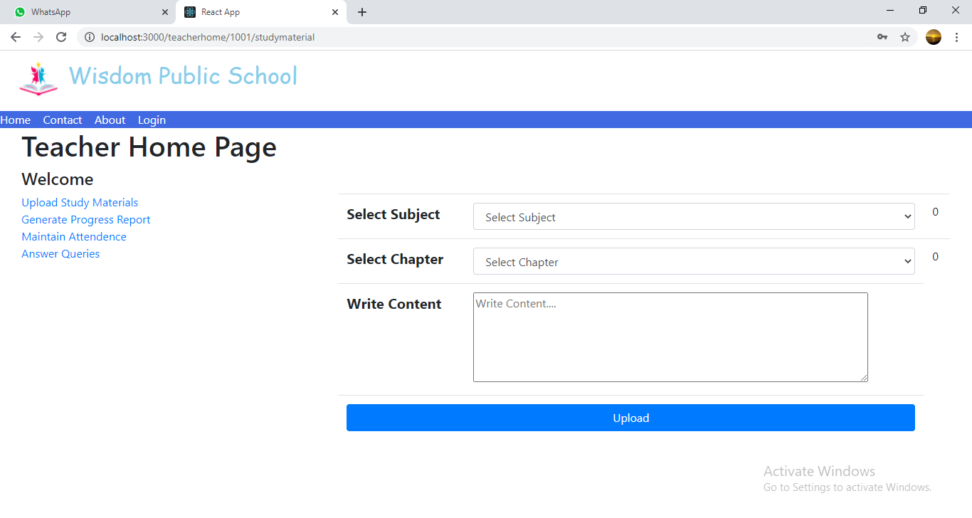

**8.6.2 Generate Progress Report Page**

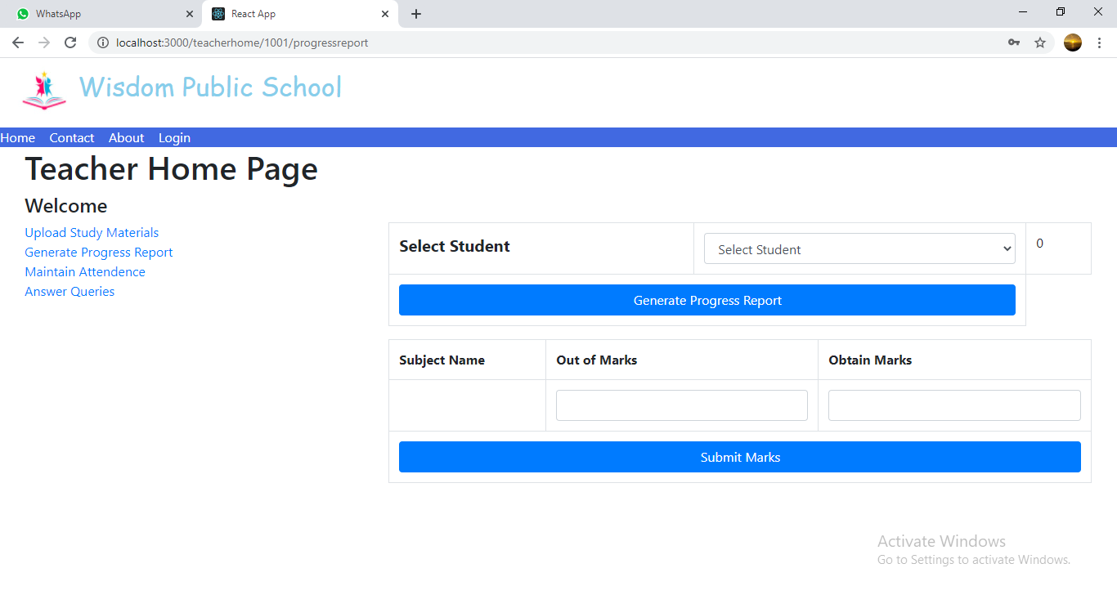

**8.6.3 Maintain Attendance Page**

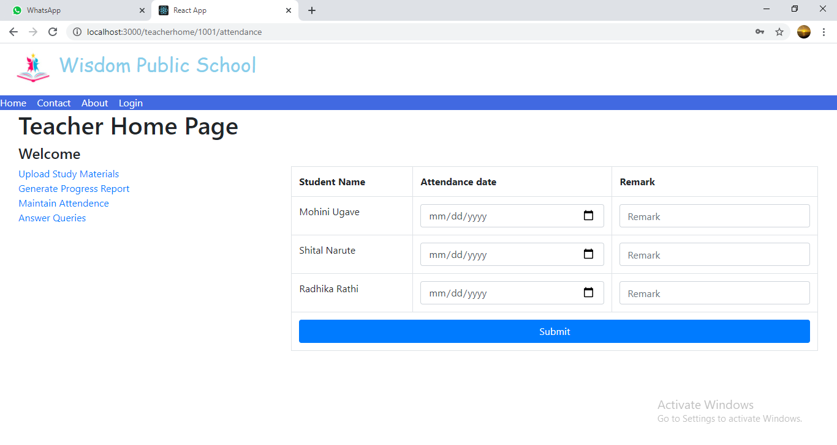

**8.6.4 Answer Queries Page**

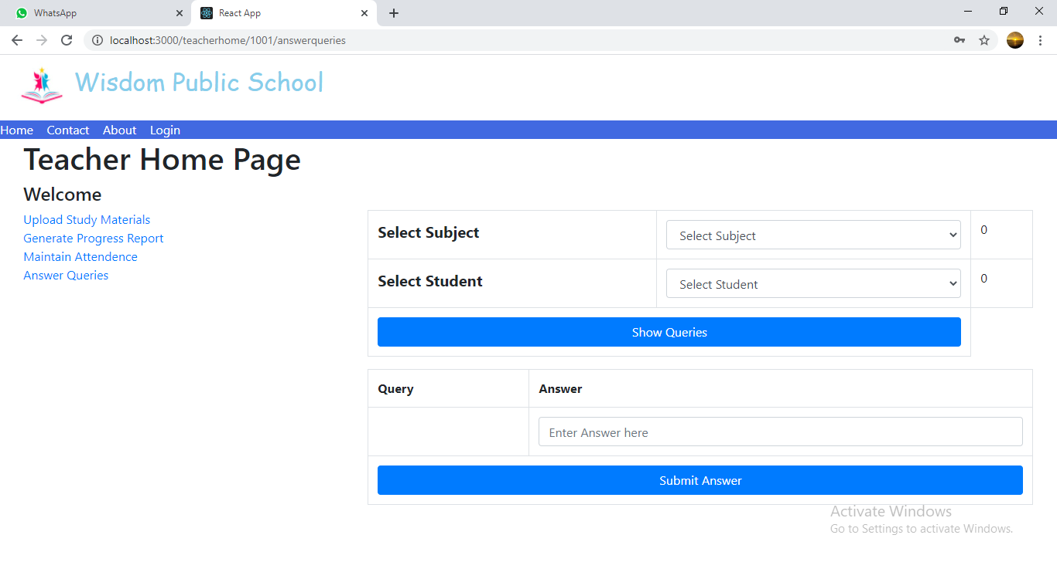

**8.7 Student Home Page**

**8.7.1 View Study Material Page**

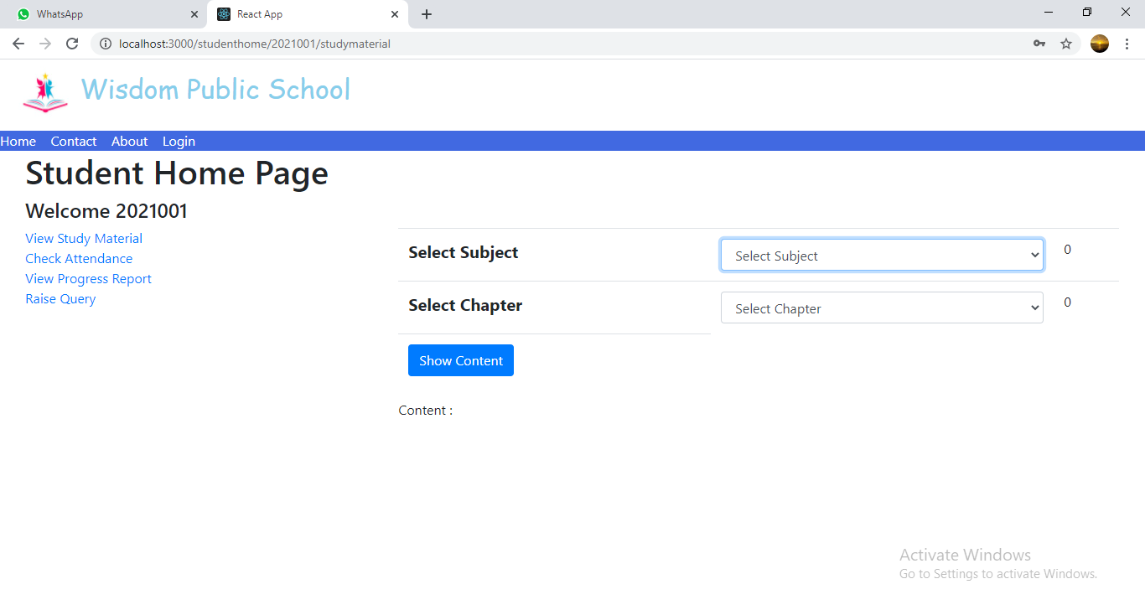

**8.7.2 Check Attendance Page**

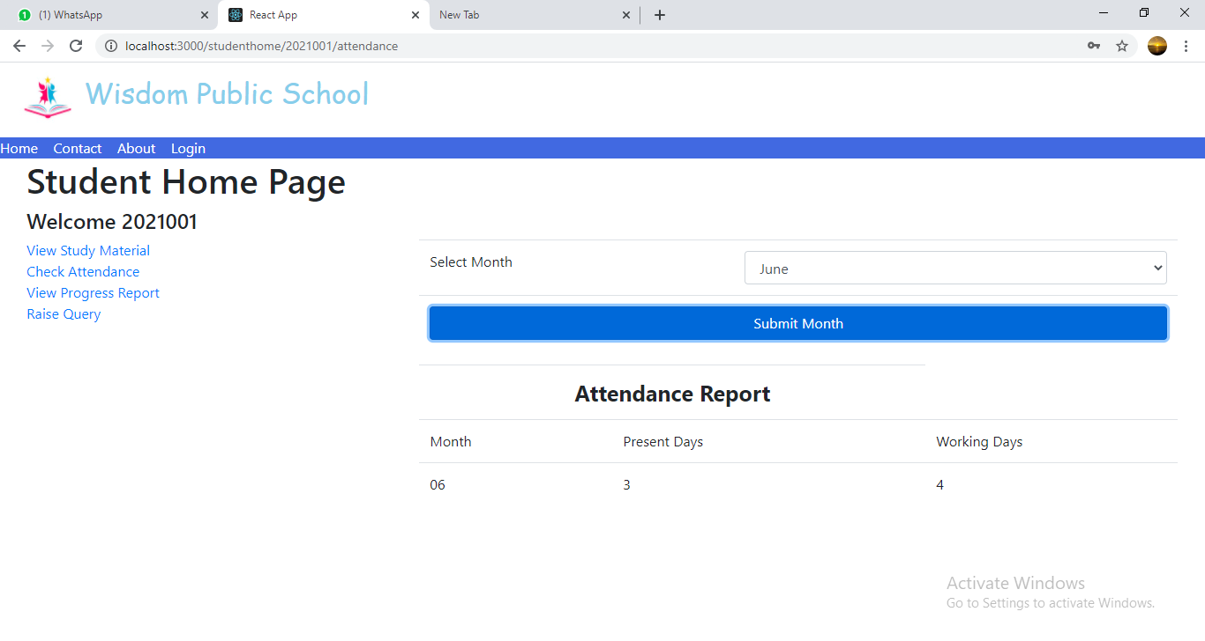

**8.7.3 View Progress Report Page**

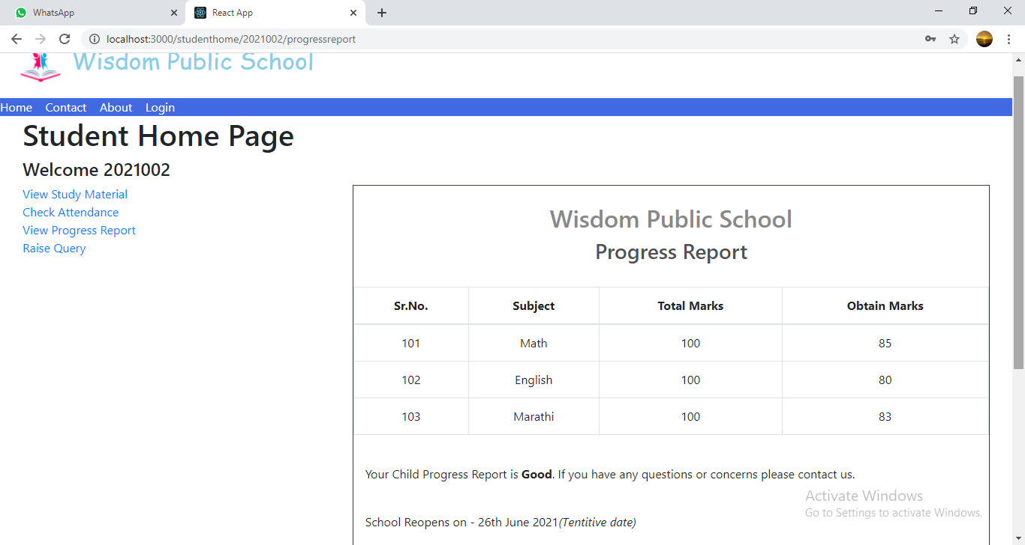

**8.7.4 Raise Query Page**

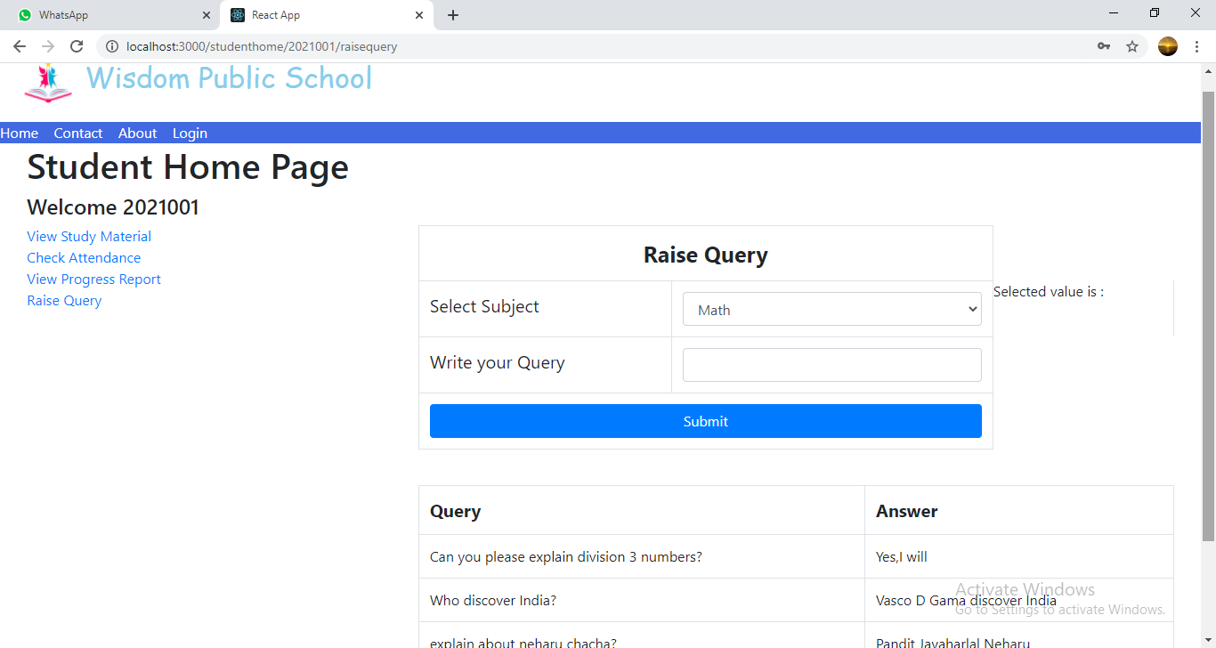

**9. CONCLUSION AND FUTURE SCOPE**

Paperless School Management System provides better education and platform to get connected with Teachers and Students efficiently.

Our System provides a very user-friendly platform where Student can easily read the study materials, check the attendance, raise the queries and view progress report, also Teacher will upload study materials, maintain attendance, answer queries and generate progress report.

Our system is aimed efficient management of various tasks like Generating time table for students on daily basis, Managing fees payment, Examination management. Digitally monitor daily activities along with managing all the resources and information on a single platform.